Assignment No.:-4

Name: Kudal Vaibhav Sonaji
Roll No.: CO-433
Class:- BE COMP (A)

Title: Implement K-Means clustering/ hierarchical clustering on sales_data_sample.csv dataset. Determine the number of clusters using the elbow method.

Importing libraries

In [198…
import pandas as pd import numpy as np import seaborn as sns
import matplotlib.pyplot as plt

In [199…
from sklearn.cluster import KMeans, k_means #For clustering
from sklearn.decomposition import PCA #Linear Dimensionality reduction.

Importing the dataset

In [200…
df = pd.read_csv("sales_data_sample.csv")

Preprocessing

In [201…
df.head()

Out[201]: | ORDERNUMBER |  | QUANTITYORDERED | PRICEEACH | ORDERLINENUMBER | SALES | ORDER | ATE | STATUS | QTR_ID
 | 0 | 10107 | 30 | 95.70 | 2 | 2871.00 | 2/24 | 2003  0:00 | Shipped | 1
 | 1 | 10121 | 34 | 81.35 | 5 | 2765.90 | 5/7 | 2003  0:00 | Shipped | 2
 | 2 | 10134 | 41 | 94.74 | 2 | 3884.34 | 7/1 | 2003  0:00 | Shipped | 3
 | 3 | 10145 | 45 | 83.26 | 6 | 3746.70 | 8/25 | 2003  0:00 | Shipped | 3
 | 4 | 10159 | 49 | 100.00 | 14 | 5205.27 | 10/10 | 2003  0:00 | Shipped | 4
5 rows × 25 columns

Out[202]:
In [202…

In [203…
df.shape

(2823, 25)

Out[203]: ORDERNUMBER QUANTITYORDERED PRICEEACH ORDERLINENUMBER SALES QTR_ID MONT

count | 2823.000000 | 2823.000000 | 2823.000000 | 2823.000000 | 2823.000000 | 2823.000000 | 2823.00
mean | 10258.725115 | 35.092809 | 83.658544 | 6.466171 | 3553.889072 | 2.717676 | 7.0
std | 92.085478 | 9.741443 | 20.174277 | 4.225841 | 1841.865106 | 1.203878 | 3.65
min | 10100.000000 | 6.000000 | 26.880000 | 1.000000 | 482.130000 | 1.000000 | 1.00
25% | 10180.000000 | 27.000000 | 68.860000 | 3.000000 | 2203.430000 | 2.000000 | 4.00
50% | 10262.000000 | 35.000000 | 95.700000 | 6.000000 | 3184.800000 | 3.000000 | 8.00
75% | 10333.500000 | 43.000000 | 100.000000 | 9.000000 | 4508.000000 | 4.000000 | 11.00
max | 10425.000000 | 97.000000 | 100.000000 | 18.000000 | 14082.800000 | 4.000000 | 12.00

In [204…

In [205… Out[205]:

<class 'pandas.core.frame.DataFrame'> RangeIndex: 2823 entries, 0 to 2822 Data columns (total 25 columns):
df.info()
# Column Non-Null Count Dtype

0 |  | ORDERNUMBER | 2823 | non-null |  | int64
1 |  | QUANTITYORDERED | 2823 | non-null |  | int64
2 |  | PRICEEACH | 2823 | non-null |  | float64
3 |  | ORDERLINENUMBER | 2823 | non-null |  | int64
4 |  | SALES | 2823 | non-null |  | float64
5 |  | ORDERDATE | 2823 | non-null |  | object
6 |  | STATUS | 2823 | non-null |  | object
7 |  | QTR_ID | 2823 | non-null |  | int64
8 |  | MONTH_ID | 2823 | non-null |  | int64
9 |  | YEAR_ID | 2823 | non-null |  | int64
10 |  | PRODUCTLINE | 2823 | non-null |  | object
11 |  | MSRP | 2823 | non-null |  | int64
12 |  | PRODUCTCODE | 2823 | non-null |  | object
13 |  | CUSTOMERNAME | 2823 | non-null |  | object
14 |  | PHONE | 2823 | non-null |  | object
15 |  | ADDRESSLINE1 | 2823 | non-null |  | object
- ADDRESSLINE2 302 non-null object
- CITY 2823 non-null object
- STATE 1337 non-null object
- POSTALCODE 2747 non-null object
- COUNTRY 2823 non-null object
- TERRITORY 1749 non-null object
- CONTACTLASTNAME 2823 non-null object
- CONTACTFIRSTNAME 2823 non-null object
- DEALSIZE 2823 non-null object dtypes: float64(2), int64(7), object(16)
memory usage: 551.5+ | KB
df.isnull().sum()
ORDERNUMBER | 0
QUANTITYORDERED | 0
PRICEEACH | 0
ORDERLINENUMBER | 0
SALES | 0
ORDERDATE | 0
STATUS | 0
QTR_ID | 0
MONTH_ID | 0
YEAR_ID | 0
PRODUCTLINE | 0
MSRP | 0
PRODUCTCODE | 0

CUSTOMERNAME 0
PHONE 0
ADDRESSLINE1 0
ADDRESSLINE2 2521
CITY 0
STATE 1486
POSTALCODE 76
COUNTRY 0
TERRITORY 1074
CONTACTLASTNAME 0
CONTACTFIRSTNAME 0
DEALSIZE 0
dtype: int64

In [206… Out[206]:

In [207…

df.dtypes
ORDERNUMBER int64
QUANTITYORDERED int64
PRICEEACH float64 ORDERLINENUMBER int64
SALES float64
ORDERDATE object
STATUS object
QTR_ID int64
MONTH_ID int64
YEAR_ID int64
PRODUCTLINE object
MSRP int64
PRODUCTCODE object
CUSTOMERNAME object
PHONE object
ADDRESSLINE1 object
ADDRESSLINE2 object
CITY object
STATE object
POSTALCODE object
COUNTRY object
TERRITORY object
CONTACTLASTNAME object
CONTACTFIRSTNAME object
DEALSIZE object
dtype: object
df_drop = ['ADDRESSLINE1', 'ADDRESSLINE2', 'STATUS','POSTALCODE', 'CITY', 'TERRITORY',
df = df.drop(df_drop, axis=1) #Dropping the categorical uneccessary columns along with c

In [208… Out[208]:

In [209…

QUANTITYORDERED 0
df.isnull().sum()
PRICEEACH 0
ORDERLINENUMBER 0
SALES 0
ORDERDATE 0
QTR_ID 0
MONTH_ID 0
YEAR_ID 0
PRODUCTLINE 0
MSRP 0
PRODUCTCODE 0
COUNTRY 0
DEALSIZE 0
dtype: int64
df.dtypes

Out[209]:

In [ ]:
QUANTITYORDERED int64
PRICEEACH float64 ORDERLINENUMBER int64
SALES float64
ORDERDATE object
QTR_ID int64
MONTH_ID int64
YEAR_ID int64
PRODUCTLINE object
MSRP int64
PRODUCTCODE object
COUNTRY object
DEALSIZE object dtype: object
# Checking the categorical columns.

In [210… Out[210]:

In [211… Out[211]:
In [212… Out[212]:

array(['USA', 'France', 'Norway', 'Australia', 'Finland', 'Austria', 'UK',
df['COUNTRY'].unique()
'Spain', 'Sweden', 'Singapore', 'Canada', 'Japan', 'Italy', 'Denmark', 'Belgium', 'Philippines', 'Germany', 'Switzerland', 'Ireland'], dtype=object)

df['PRODUCTLINE'].unique()
array(['Motorcycles', 'Classic Cars', 'Trucks and Buses', 'Vintage Cars', 'Planes', 'Ships', 'Trains'], dtype=object)

df['DEALSIZE'].unique()
array(['Small', 'Medium', 'Large'], dtype=object)

In | [213… | productline = pd.get_dummies(df['PRODUCTLINE']) #Converting the categorical columns.  Dealsize = pd.get_dummies(df['DEALSIZE'])
In | [214… | df = pd.concat([df,productline,Dealsize], axis = 1)
In | [215… | df_drop = ['COUNTRY','PRODUCTLINE','DEALSIZE'] #Dropping Country too as there are alot  df = df.drop(df_drop, axis=1)
In | [216… | df['PRODUCTCODE'] = pd.Categorical(df['PRODUCTCODE']).codes #Converting the datatype.
In | [217… | df.drop('ORDERDATE', axis=1, inplace=True) #Dropping the Orderdate as Month is already i
In | [218… | df.dtypes #All the datatypes are converted into numeric
Out[218]: |  | QUANTITYORDERED  PRICEEACH ORDERLINENUMBER | int64  float64 int64
 |  | SALES QTR_ID MONTH_ID YEAR_ID | float64 int64 int64 int64
 |  | MSRP PRODUCTCODE  Classic Cars  Motorcycles | int64 int8 uint8 uint8
 |  | Planes Ships Trains  Trucks and Buses | uint8 uint8 uint8  uint8
 |  | Vintage Cars | uint8

Large uint8
Medium uint8
Small uint8
dtype: object

Plotting the Elbow Plot to determine the number of clusters.

In [219…
distortions = [] # Within Cluster Sum of Squares from the centroid
K = range(1,10)
for k in K:
kmeanModel = KMeans(n_clusters=k) kmeanModel.fit(df)
distortions.append(kmeanModel.inertia_) #Appeding the intertia to the Distortions

In [220…
plt.figure(figsize=(16,8)) plt.plot(K, distortions, 'bx-') plt.xlabel('k') plt.ylabel('Distortion')
plt.title('The Elbow Method showing the optimal k') plt.show()

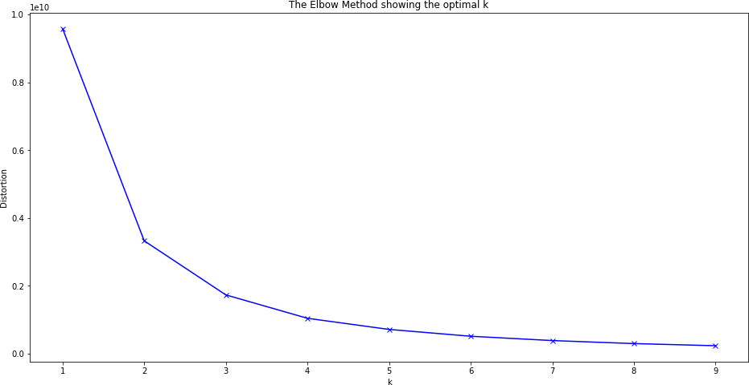

As the number of k increases Inertia decreases.
Observations: A Elbow can be observed at 3 and after that the curve decreases gradually.
In [221… In [222…
X_train.shape
X_train = df.values #Returns a numpy array.
Out[222]: (2823, 19)

In [223…
model = KMeans(n_clusters=3,random_state=2) #Number of cluster = 3
model = model.fit(X_train) #Fitting the values to create a model.
predictions = model.predict(X_train) #Predicting the cluster values (0,1,or 2)

In [225… In [226… In [227…
counts_df.head()
counts_df = pd.DataFrame(counts,columns=['Cluster1','Cluster2','Cluster3'])
counts = counts.reshape(1,3)
unique,counts = np.unique(predictions,return_counts=True)
In [228…

Out[228]:

In [229…
Cluster1 Cluster2 Cluster3

0 1083 1367 373

Visualization

In [230… In [231…
reduced_X.head()
reduced_X = pd.DataFrame(pca.fit_transform(X_train),columns=['PCA1','PCA2']) #Creating a
pca = PCA(n_components=2) #Converting all the features into 2 columns to make it easy to

Out[231]: | PCA1 | PCA2
0 | -682.488323 | -42.819535
1 | -787.665502 | -41.694991
2 | 330.732170 | -26.481208
3 | 193.040232 | -26.285766
4 | 1651.532874 | -6.891196

In [232…
#Plotting the normal Scatter Plot plt.figure(figsize=(14,10)) plt.scatter(reduced_X['PCA1'],reduced_X['PCA2'])

Out[232]: <matplotlib.collections.PathCollection at 0x218dc747880>

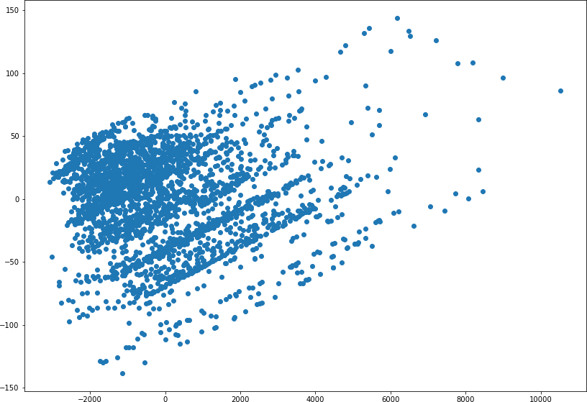

In [233… Out[233]:
model.cluster_centers_ #Finding the centriods. (3 Centriods in total. Each Array contain

In [234…

array([[ 3.72031394e+01, | 9.52120960e+01, | 6.44967682e+00,
4.13868425e+03, | 2.72022161e+00, | 7.09879963e+00,
2.00379409e+03, | 1.13248384e+02, | 5.04469067e+01,
3.74884580e-01, | 1.15420129e-01, | 9.41828255e-02,
8.21791320e-02, | 1.84672207e-02, | 1.16343490e-01,
1.98522622e-01,  -6.66133815e-16], | 2.08166817e-17, | 1.00000000e+00,
[ 3.08302853e+01, | 7.00755230e+01, | 6.67300658e+00,
2.12409474e+03, | 2.71762985e+00, | 7.09509876e+00,
2.00381127e+03, | 7.84784199e+01, | 6.24871982e+01,
2.64813460e-01, | 1.21433797e-01, | 1.29480614e-01,
1.00219459e-01, | 3.87710315e-02, | 9.21726408e-02,
2.53108998e-01, | 6.93889390e-18, | 6.21799561e-02,
9.37820044e-01],  [ 4.45871314e+01, | 9.98931099e+01, | 5.75603217e+00,
7.09596863e+03, | 2.71045576e+00, | 7.06434316e+00,
2.00389008e+03, | 1.45823056e+02, | 3.14959786e+01,
5.33512064e-01, | 1.07238606e-01, | 7.23860590e-02,
2.14477212e-02, | 1.07238606e-02, | 1.31367292e-01,
1.23324397e-01, | 4.20911528e-01, | 5.79088472e-01,
5.55111512e-17]])
reduced_centers = pca.transform(model.cluster_centers_) #Transforming the centroids into

In [235… Out[235]:

In [236…

array([[ 5.84994044e+02, -4.36786931e+00], [-1.43005891e+03, 2.60041009e+00], [ 3.54247180e+03, 3.15185487e+00]])
plt.figure(figsize=(14,10)) plt.scatter(reduced_X['PCA1'],reduced_X['PCA2'])
reduced_centers

plt.scatter(reduced_centers[:,0],reduced_centers[:,1],color='black',marker='x',s=300) #P

Out[236]:

In [237…
reduced_X['Clusters'] = predictions #Adding the Clusters to the reduced dataframe.
<matplotlib.collections.PathCollection at 0x218deb6e220>
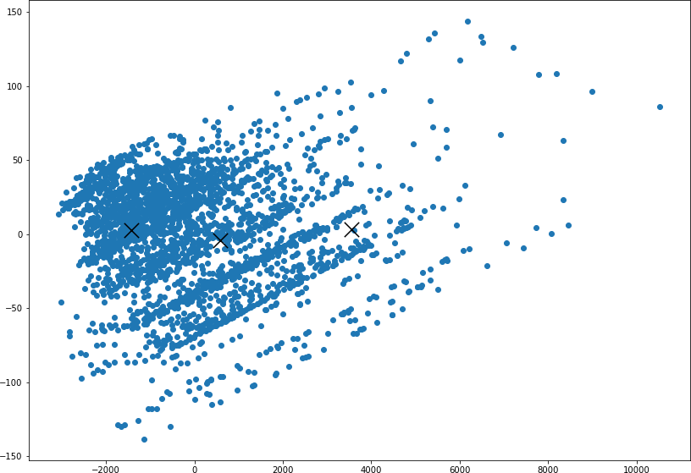

In [238…
reduced_X.head()

Out[238]: | PCA1 | PCA2 | Clusters
0 | -682.488323 | -42.819535 | 1
1 | -787.665502 | -41.694991 | 1
2 | 330.732170 | -26.481208 | 0
3 | 193.040232 | -26.285766 | 0
4 | 1651.532874 | -6.891196 | 0

In [239…
#Plotting the clusters
plt.figure(figsize=(14,10))
#
taking the cluster number and first column
taking the sa
plt.scatter(reduced_X[reduced_X['Clusters'] == 0].loc[:,'PCA1'],reduced_X[reduced_X['Clu plt.scatter(reduced_X[reduced_X['Clusters'] == 1].loc[:,'PCA1'],reduced_X[reduced_X['Clu
plt.scatter(reduced_X[reduced_X['Clusters'] == 2].loc[:,'PCA1'],reduced_X[reduced_X['Clu
plt.scatter(reduced_centers[:,0],reduced_centers[:,1],color='black',marker='x',s=300)

Out[239]: <matplotlib.collections.PathCollection at 0x218dce9e1f0>

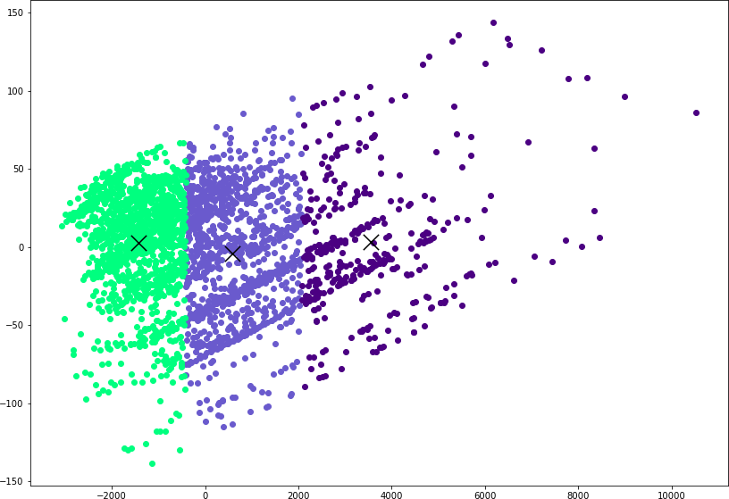

In [ ]:

